**Management Plan**

**Gantt Chart:**

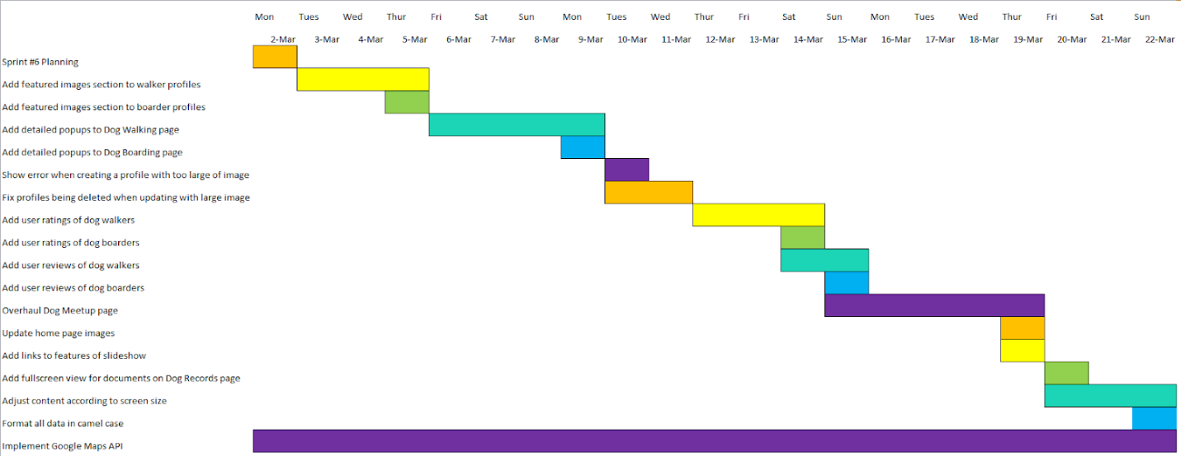

**Sprint Goal:**

Add popups to Dog walking and Dog boarding pages. Overhaul Meetup page to same level of quality as others. Replace Home page images and add links over slide show. Implement Google Places API. Work on the machine learning model.

**Sprint Retrospective:**

We finished all the tasks planned for this sprint. We planned 43 points and we were able to finish it all. Team commitment: 4 hours per person for 3 weeks which adds up to 72 hours for 6 people. Despite transitioning to entirely online collaboration due to the ongoing pandemic, the team’s use of Git prevented any major delays. In our next sprint, our team should schedule regular online meetings. We decided based on which pages lacked quality. There are zero user stories in progress. Progress was mostly linear with large stories being completed near the end of the sprint. Many new featured will require user feedback. Google Maps API is difficult to implement.